Day #13 – Apply for your DUNS number

Welcome to ‘Govcon Dummies Free Course’ Day #13.

This is your Tax ID number needed to get registered.

If you have the corporation up and running than you can start this step.

Learn how to setup a DUNS number today.
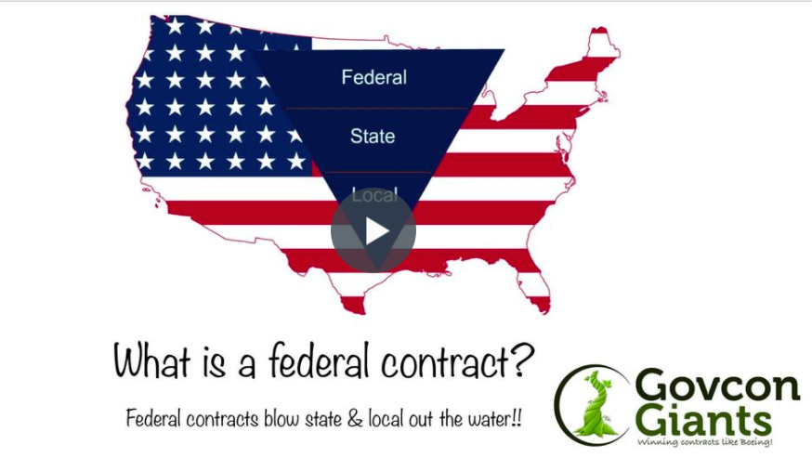

If you have watched the video online but not done the steps, watch this one which explains in more detail.

Again, you don’t want to take anything for granted here. Do each step, you’ll have plenty of time to win contracts.

Pick a name! Any name!

Big hug,

Eric Coffie

